Office 365 Install
- Sign in to www.office.com.
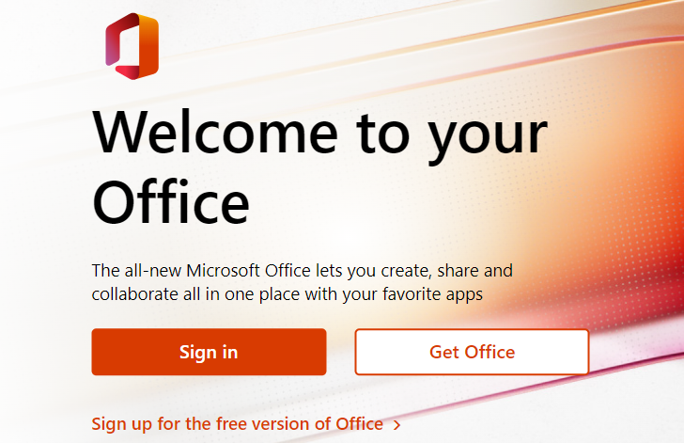
- Use your swbts.edu email address.
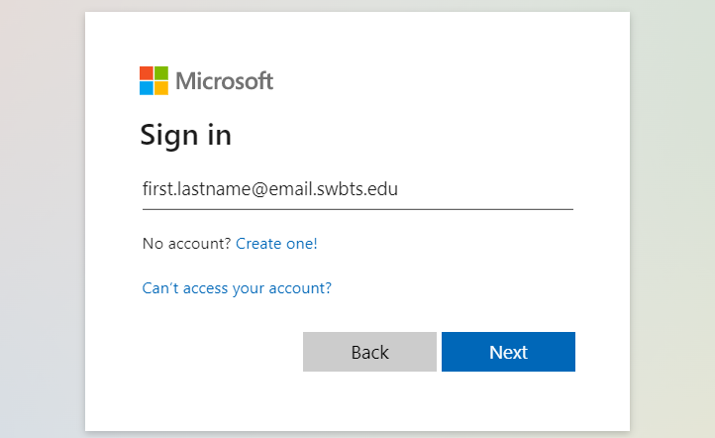
- After logging in, the top right of the home page will have an Install Office button. Click here and select Download Office 365 apps.
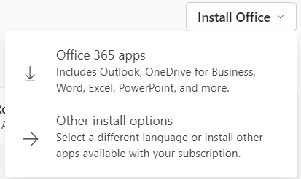
- In the computer’s Downloads folder, there is now a program to install Office. Run OfficeSetup.exe
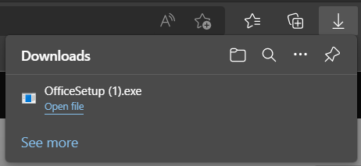
- You now have access to the full suite of Office 365. For any sign-ins, use your SWBTS email address and password.
Need further assistance?
Contact Campus Technology at (817) 921-8555 or campustechnology@swbts.edu

